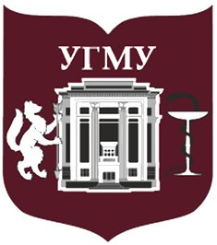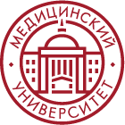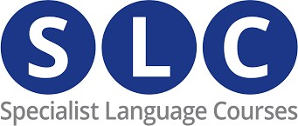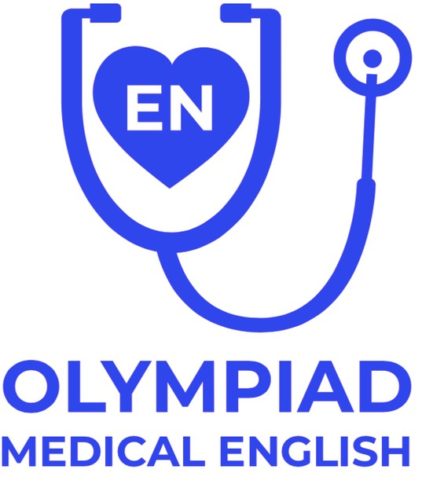

int.medenglish@mail.ru

INFORMATION LETTER

The 4th International English Language Competition for medical and pharmaceutical students ONLINE
(November 2021 – April 2022)

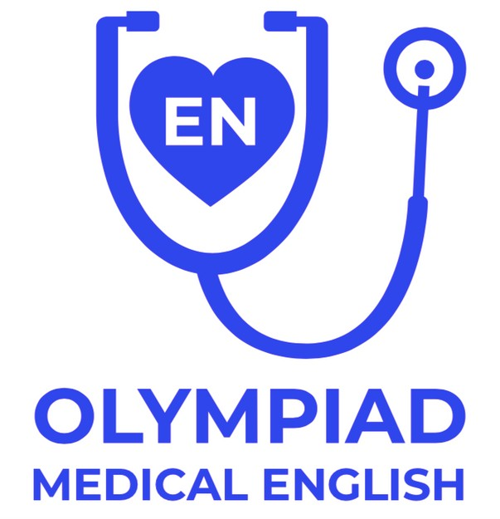

I.M. Sechenov First Moscow State Medical University (Sechenov University), Ural State Medical University (USMU) and Prof. V.F. Voino-Yasenetsky Krasnoyarsk State Medical University (KrasSMU) are announcing conduction of the Fourth International English Language Competition for medical and pharmaceutical students (hereinafter – the Olympiad).
The Olympiad is conducted under the guidance of Educational and Methodical Commission in linguistic disciplines for the enlarged group of specialties 31.00.00 – Clinical Medicine at the “Public Health and Medical Science” Coordination Council on Education of the Ministry of Education and Science of the Russian Federation (hereinafter - EMC) and supported by Specialist Language Course, Ltd..
The Olympiad is open to students, residents and post-graduates of both Russian and international medical and pharmaceutical faculties and universities.
The Olympiad is conducted in the form of contests for students in creative application of generic and professional competencies acquired in the course of learning the “Foreign Language” discipline (the English language).
The aim of the Olympiad is to improve the quality of training for medical and pharmaceutical students as well as to enhance the students’ motivation to learn the English language as a means for international professional communication and lifelong professional development.

ORGANISATION OF THE OLYMPIAD
- GENERAL POINTS

The Olympiad includes two contests; the individual contest and the team contest. All participants of the Olympiad should be citizens of the country where English is NOT an official language.
- Both first and second-year medical and pharmaceutical students are invited to participate in the individual contest. Teams of up to six students that may include undergraduate students (regardless of their year of study) and postgraduate students are admitted to the team contest.

The individual contest is run in four rounds. Registration, the qualifying round, the first round and the second round of the individual contest are held virtually as an absentia competition. The third round of the Olympiad is held at the premises of Sechenov University (Moscow) in the form of participation in an interuniversity profession-oriented creative language project.
- The team contest is a separate competition; the captain of the team cannot participate in the individual contest. Both submission of works for the team contest and announcement of the contest results are conducted virtually in absentia. The captains of the team winners are invited to participate in the third round the Olympiad held at the premises of Sechenov University (Moscow) in the form of participation in an interuniversity profession-oriented creative language project along with the finalists of the individual contest.
- No participation fees are charged.

- ORGANISATION AND PROCEDURE OF REGISTRATION
- Registration for individual contest of the Olympiad is done online on the following Olympiad webpage https://edu.usma.ru/course/view.php?id=581
- Each participating university has the right to appoint any number of first and second-year medical and pharmaceutical students for the individual contest.
- Self registration of the participants is opened from November 1, 2021 till November 30, 2021. Participants of the Olympiad check the access to the materials of the Olympiad themselves using their login and password on the following Olympiad webpage https://edu.usma.ru/course/view.php?id=581
. Access to the materials of the Olympiad is opened within three working days after the registration. If participants cannot access the materials of the Olympiad they should inform the organising committee via e-mail int.medenglish@mail.ru.
- For registration of team contest participants, team captains send an application (see below) to e- mail addresses of the organising committee (int.medenglish@mail.ru ) within the period from November 1, 2021 till November 30, 2021. and also register on the following Olympiad webpage https://edu.usma.ru/course/view.php?id=581 .

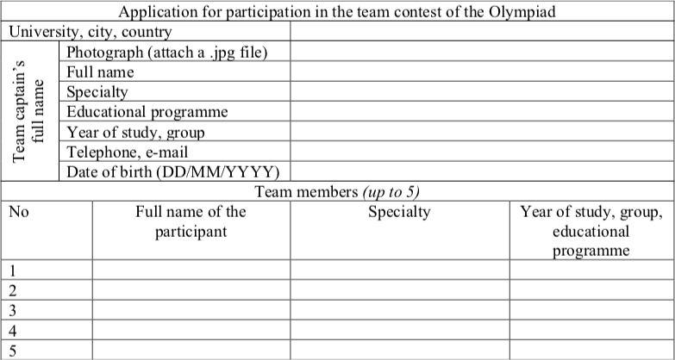

Teams of up to six students might participate in the team contest (the captain and up to five team members). Information about registered teams is placed both Olympiad webpages https://edu.usma.ru/course/view.php?id=581 and https://intcom.krasgmu.ru/index.php?page[self]=olympiad_2021_22&lang=Ru

ORGANISATION AND PROCEDURE OF THE QUALIFYING ROUND IN THE INDIVIDUAL CONTEST OF THE OLYMPIAD
- The qualifying round of the individual contest of the Olympiad is held on websites of the organising universities online whenever convenient to participants within 24 hours on December 4, 2021 (Moscow time).
- All first and second-year medical and pharmaceutical students of Russian universities, as well as those at medical faculties of international universities having registered on or prior to
November 30, 2021 on the Olympiad webpage are admitted to the Olympiad.
- The task for the first round of the Olympiad includes a test of grammar and vocabulary. The tasks are checked automatically. Results of the qualifying round of the individual contest are summarised within 5 consecutive days and published on the Olympiad webpage on December 8, 2021. No more than 140 students who scored maximum points in the qualifying round are invited to the first round.

ORGANISATION AND PROCEDURE OF THE FIRST ROUND IN THE INDIVIDUAL CONTEST OF THE OLYMPIAD

- The first round of the Olympiad is held on websites of the organising universities online whenever convenient to participants within 24 hours on December 11, 2021 (Moscow time).
- Tasks for the first round of the Olympiad include: a test of reading comprehension and a listening comprehension test. The tasks are checked automatically.
- Results of the first round of the individual contest are summarised within 5 consecutive days and published on the Olympiad webpage on December 15, 2021.
No more than 60 students who scored maximum points in the first round are invited to the second round (this number may increase in case of a certain number of participants with equal results).

ORGANISATION AND PROCEDURE OF THE SECOND ROUND IN THE INDIVIDUAL CONTEST OF THE OLYMPIAD

  - The second round of the Olympiad is held within 28 consecutive days after summarising the first round from December 16, 2021 through January 15, 2022.
  - Participants of the individual contest admitted to the second round are to provide a video- message in English lasting 1.5-3 minutes on the topic “Modern Medicine knows no borders” to the organisational committee by January 15. 2022 no later than at 23:59 (Moscow time). An instruction on the theme, regulations concerning provision of video-messages and requirements to them will be published on websites of the Olympiad on or prior to November 10, 2021. Video-messages of all participants of this round are published on open access on corresponding webpages of the Olympiad’s organising universities.
- By providing a video-message the participants of the Olympiad agree to make their video public and open access by the organising committee for the purpose of the competition.
- Assessment of works provided for the second round of the Olympiad is performed by the Jury according to parameters approved by the organising committee and published on he Olympiad webpage on or prior to November 10, 2021.
- Results of the second round are summarised by the Olympiad Jury with assistance of international experts-representatives within 30 consecutive days after the end of the second round and are published on the Olympiad webpage before February 15, 2022. Winners of the second round (16-20 students) are invited to participate in the third (final) round of the Olympiad.

ORGANISATION AND PROCEDURE OF THE THIRD (FINAL) ROUND IN THE INDIVIDUAL CONTEST OF THE OLYMPIAD

  - Third round of the Olympiad is held at the premises of Sechenov University (Moscow) online in April 2022 (the exact date will be announced later) and represent participation in an interuniversity profession-oriented creative language project. Instructions for the participants of the final round are provided before its beginning on the same day.

ORGANISATION AND PROCEDURE OF THE TEAM CONTEST OF THE OLYMPIAD

- All registered teams from participating universities are admitted to the Olympiad.
- Participants of the team contest must provide UNIVERSITY PROMOTIONAL VIDEO in English lasting for 3-5 minutes to the organising committee within the period from December 1, 2021 to January 15, 2022 no later than at 23:59 (Moscow time). The aim of the project is the demonstration of competitive advantage of the country, city, and university for international students.
An instruction for provision of video-messages will be published on the Olympiad webpage.
.Video-messages of all participants will be published on open access on the Olympiad webpage. By providing a video-message the participants of the Olympiad agree to make their video public and open access by the organising committee for the purpose of the competition.
- Participants of the team contest should publish their video on the official site of the university and/or official webpage of the University in the social networks and/or webpages of university students' communities in the social networks marked with the hashtag #medengolymp no later than on January 25, 2022.
- Assessment of works provided for the second round of the Olympiad is performed by the Jury according to parameters approved by the organising committee and brought to the notice of the Olympiad’s participants in advance. Results of the team contest of the Olympiad are summarised by the Olympiad Jury with assistance of international experts-representatives within 30 consecutive days after the end of video-messages receipt and are published on websites of organising universities prior to or on February 15, 2022.
- Team captains of team-winners are invited to participate in the third (final) round of the Olympiad (see VI. Organisation and procedure of the third (final) round in the individual contest of the Olympiad ).

.

- SUMMARISING RESULTS OF THE OLYMPIAD
- Participants (in the individual contest) or teams (in the team contest) with highest scores following the results of competitions (of three rounds for the individual contest) of the Olympiad are considered as winners. When determining winners, the preference is given to works (performances) in which professional and generic competences formed in the course of English studies are manifested most fully.
- Results of the individual contest are summarised after conclusion of the third round of the Olympiad in April 2022.
- Results of the team contest of the Olympiad are summarised on February 15, 2020.
- Participants of the second round of the individual contest may be awarded with the Certificate of Appreciation of the Olympiad organising committee. Winners of the third round of the Olympiad are granted diplomas and memorable gifts determined by the organising committee of the Olympiad.
- Participants of the team contest of the Olympiad may be awarded with the Certificate of Appreciation of the Olympiad organising committee. Winners or the team contests are granted diplomas and memorable gifts determined by the organising committee of the Olympiad.
- The organising committee of the Olympiad reserves the right to nominate students that have demonstrated high creative potential at performance of second round tasks in the individual and team contests for awards.
- Awarding winners of the Olympiad is organised by the organising committee and is done within 30 consecutive days after the end of the Olympiad.
- Results of the Olympiad are published on websites of organising universities and on the Olympiad webpage on or prior to April 30, 2022.

