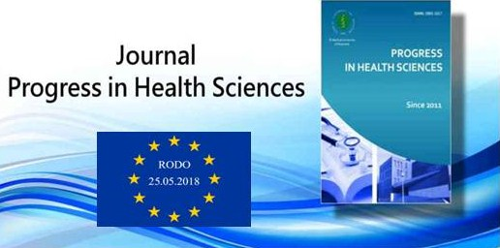

- Articles in Progress in Health Sciences are published in the open access model, and the rules for their use are set out in the Creative Commons Attribution License - Non-commercial Use 3.0 Poland (CC BY-NC). Detailed rules can be found at http://creativecommons.org/licenses/by-nc/3.0/pl.
- Versions of articles available in the open acces model
- online first - author's version of the article after corrections suggested by reviewers - accepted for publication in the journal Progress in Health Sciences are available at http://progress.umb.edu.pl/ until the final version of the article
- the final version of the article is available in the open access model at the website: http://progress.umb.edu.pl/ and https: //doi.org / ... after sending the pages and the DOI number
- The editorial staff recommends using the published version of the article posted on the journal's website - http://progress.umb.edu.pl/

RODO (General Data Protection Regulation, GDPR) - personal data
- Please be advised that your data is processed by the editors of the Progress in Health Sciences journal.
- Part of the data of the authors, reviewers, members of the scientific council of the journal, name and surname, scientific affiliation, employment address, business e-mail address are publicly available on our websites, in online magazines and dissemination only with related scientific articles.
- The personal data of the authors, reviewers, members of the scientific council of the journal will be kept during the implementation of editorial tasks (publication of scientific articles), as long as there will be a journal Progress in Health Sciences.
- Data will be processed until you withdraw your consent. The consent can be withdrawn at any time. Withdrawal of consent does not affect the legality of the processing carried out prior to its withdrawal.
- The above data will not be disclosed to third parties in any other way. The basis for sharing is indispensability to perform our tasks (Article 6 (1) (b) of the General Data Protection Regulation, GDPR).
- Lack of consent to share the above data results in the inability to carry out our tasks, that is, publishing scientific articles.
- A person participating in the publishing process of Editorial and Publishing Committee of the Progress in Health Sciences is required to submit a statement regarding the consent for the processing of personal data necessary to carry out the publishing process and dissemination of the article by the Publisher (Medical University of Bialystok).
- The author submitting work on behalf of himself and his co-authors is required to obtain their prior written consent for the processing of personal data and to provide it to the Publisher.
- The author submitting the work (and possible co-authors) is required to conclude an agreement concerning the transfer the copyrights of the work to the Publisher (Authors’ Contributions Form; Transfer of Copyright and Publishing Statement).
- The contract form, after downloading from the editorial system, printing, and signing by the Author (all co-authors). The contract form after scanning must be entered into this system during the submission of the work or sent to the editor's address.
- In regard to the processing by the editors of your data you have the number of rights - you can: get information about how and to what extent we process your data or request a rectification of your data (if they are misspelled or if you have changed), remove them (if not has a basis for us to process them);
- If you consider that the processing of data by us violates your rights, you have the right to complain to the supervisory body [in Poland - the President of the Office for Personal Data Protection (until May 25, 2018, called the Inspector General for Personal Data Protection).

